Account Access Guide:
- Enter Verification Code, and click the button below.
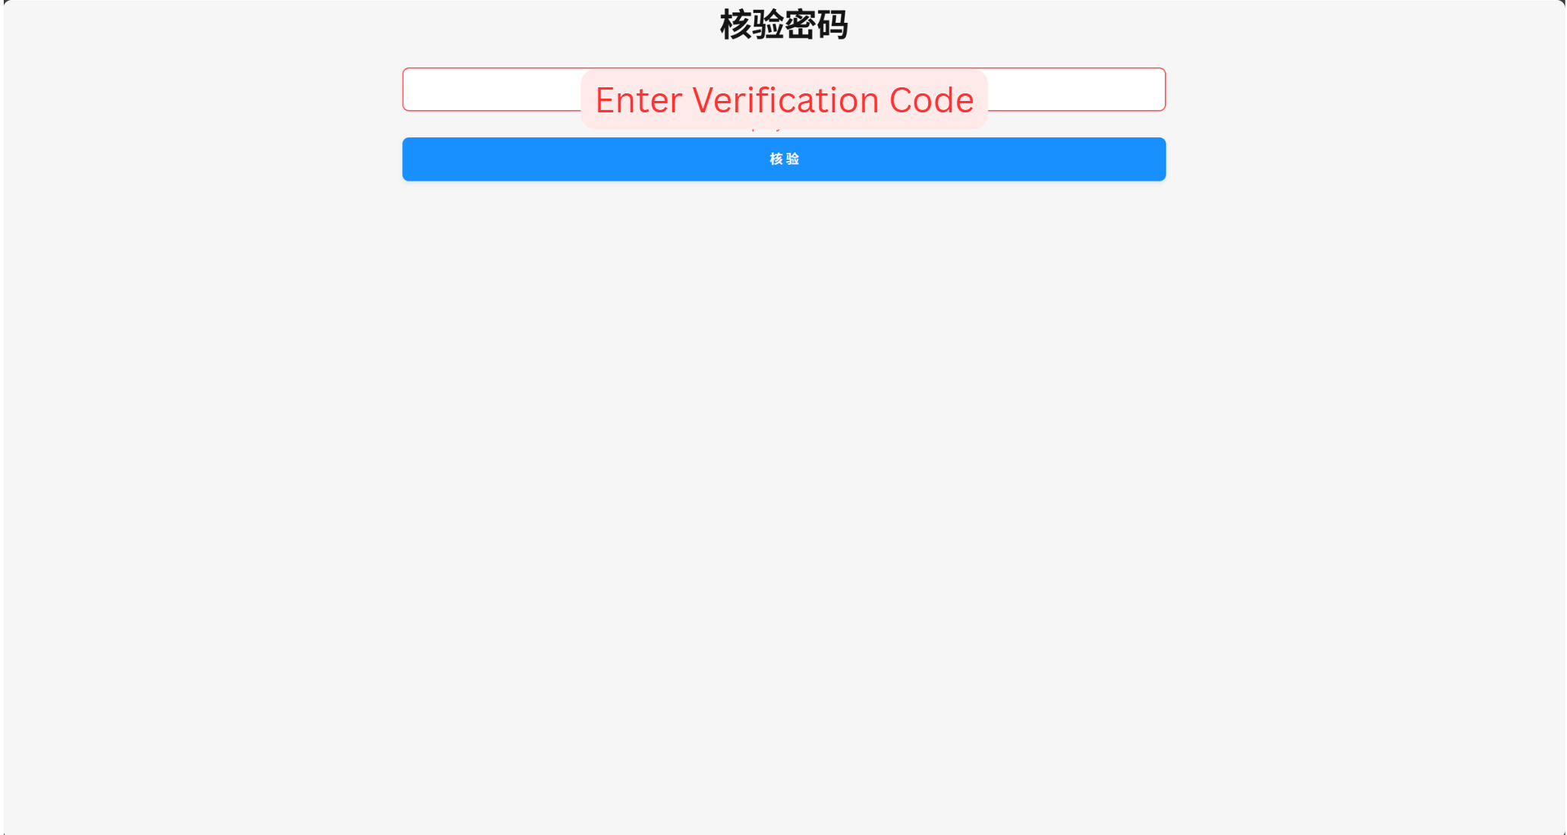

- Login to steam account from the link provided and click on the purple button for steam Guard Code.
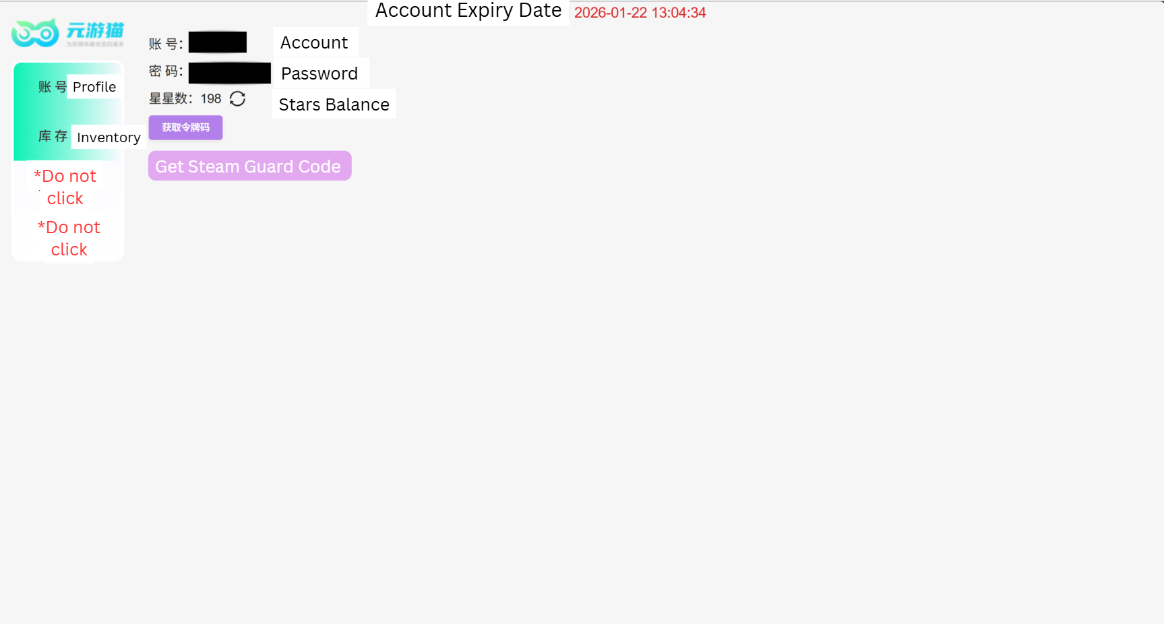

- Redeem the items.
After the 7-day cooldown period ends, you may again use the delivery link to your inventory link.
